Hand Spring/Tendon Constant Mechanical Circuit
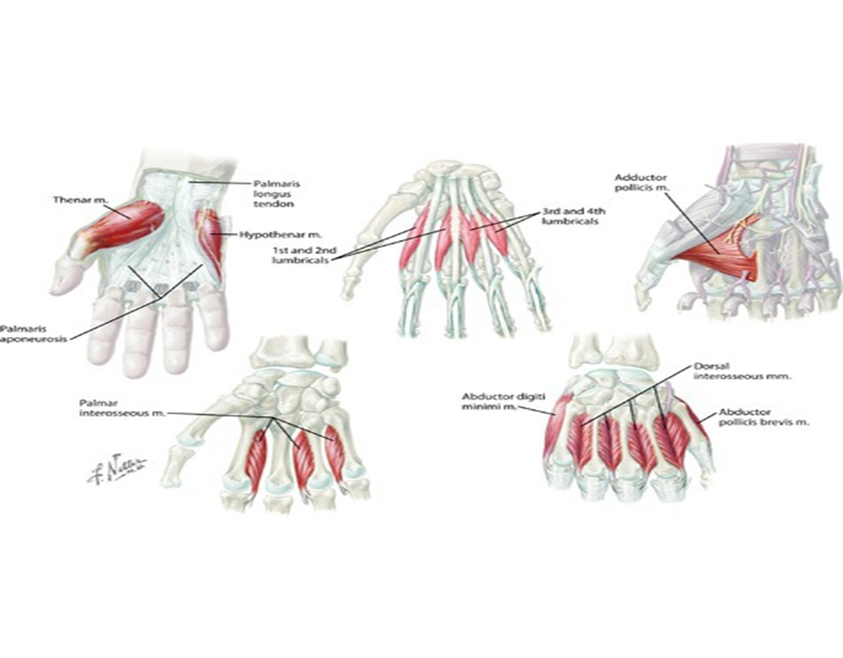

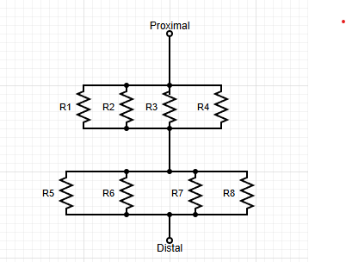

https://pmc.ncbi.nlm.nih.gov/articles/PMC3879019/#:~:text=In%20normal%20hand%20function%2C%20the,interphalangeal%20joints%20(IP)%20extension.
https://www.sciencedirect.com/science/article/abs/pii/S0021929013003850#:~:text=A%20force%2Ddisplacement%20apparatus%20was,%2C%20nerves%2C%20blood%20vessels).
Brachial Spring/Tendon Constant Mechanical Circuit

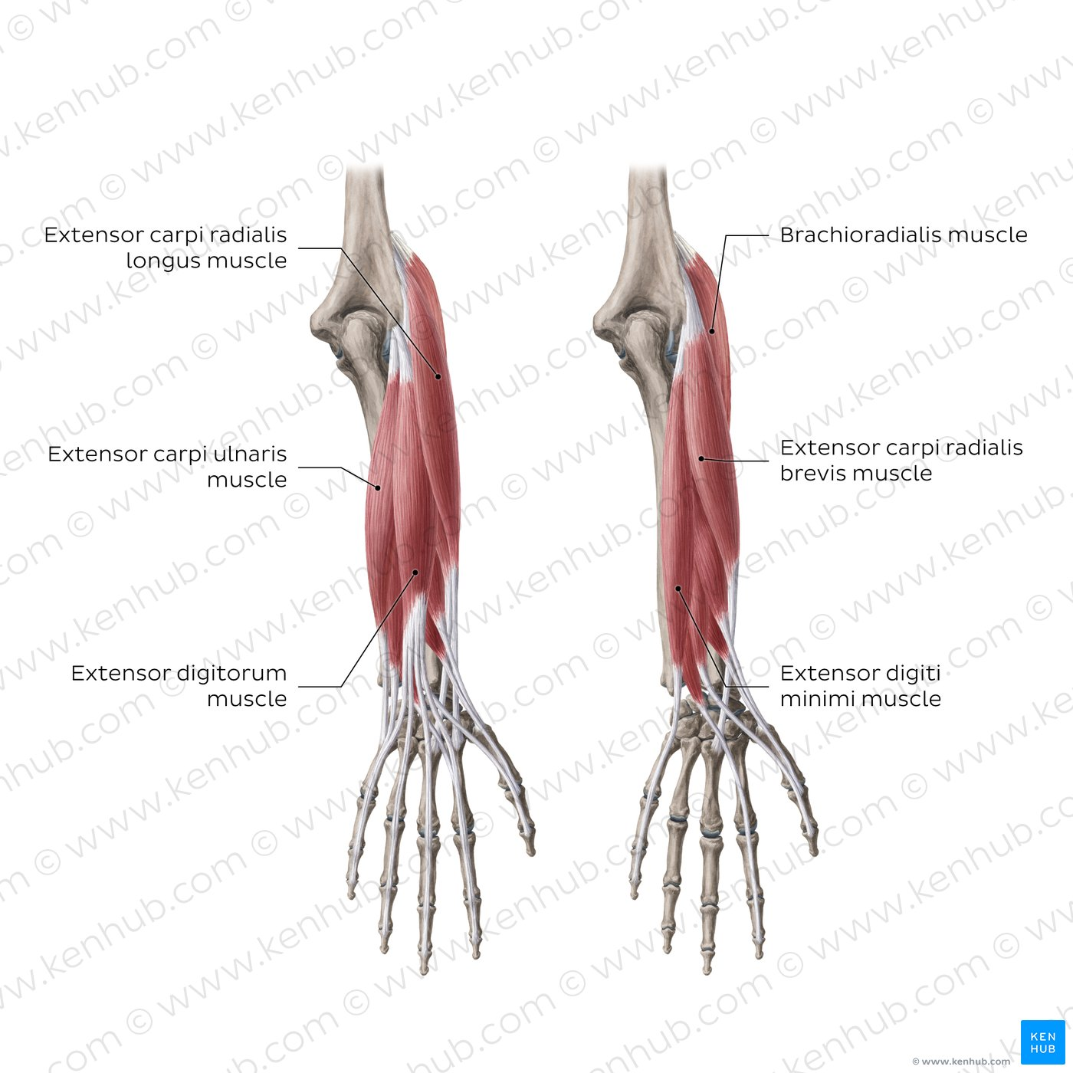
https://www.kenhub.com/en/library/anatomy/elbow-and-forearm

